**02 – Ohm’s Law**

**Topics:** Ohm’s law, continuity equation, boundary conditions on the electric field inside a conductor

**Summary:** A steady current flowing through a cone-shaped resistor is used as the context for addressing the implications of the microscopic version of Ohm’s Law . The initial multiple-choice question orients students to the situation by having them consider the current density inside the resistive material. They are then led to make conclusions about the electric field and local charge density inside the resistor by using Ohm’s law in conjunction with the continuity equation and Gauss’ law. Students are presented with two possible configurations for the electric field inside the conductor, and are asked to identify which aspects of those configurations are allowed, and which are precluded by boundary conditions or conservation of charge/current. The final activity asks them to interpret a graph of the correct field and equipotential lines inside the resistor in terms of the concepts discussed in the previous sections.

**Supporting Material:** J. D. Romano and R. H. Price, The conical resistor conundrum: A potential solution. *Am. J. Phys.* **64**, 1150-1153 (1996)

**Written by:** Charles Baily, Michael Dubson and Steven Pollock.

**Contact:** Steven.Pollock@Colorado.EDU

**Comments:** Most students should be able to complete this activity in less than 50 minutes. The initial multiple-choice question has been previously used as an in-class concept question, so one suggestion is to instead orient students to the situation using clickers and follow-up discussion, then have them work in small groups on the remaining questions. There is an assumption that students have already had some kind of introduction to Ohm’s law. We have tried to be as explicit as possible in this first question, but many students may still think they’re being asked about the current density *everywhere* inside the resistor, and not just at the edge, as indicated by the arrow. Instructors should be sure that students reconcile their mathematical conclusions ( inside the resistor) and the fact that the correct field lines are spreading outwards (which may *look* to them like a “diverging” field). It is not essential that the field lines drawn by students on the second page are completely correct before moving on – we just want them to develop some kind of expectation for what they ought to look like. In the final challenge question, the electric field at the corners of the resistor must approach zero in order to satisfy incompatible boundary conditions (simultaneously parallel with the side and perpendicular to the metal surface) – some students may anticipate this result before reaching the final page, but many might not realize until asked to interpret the graph that the two boundary conditions are incompatible there.

**A.** A steady current  flows through conducting wires that are connected to two metal disks that cap the ends of a cone-shaped resistor (made from a material with uniform conductivity σ). There is a potential difference V0 between the two metal end caps.

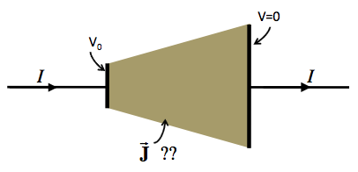

What can you conclude about the direction of the current density vector  *right at the inside wall* of the resistor? [for example, the point indicated by the arrow in the diagram]

1. Must be exactly parallel with the sides.
2. Must be exactly perpendicular to the sides.
3. Could have a mix of parallel and perpendicular components.
4. No obvious way to decide.

Briefly explain your reasoning.

You may continue, but be sure to check your answers to this part with an instructor.

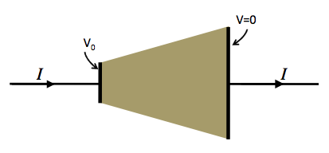

**B.** When there is a steady current flowing, is the time-derivative of the charge density  *inside* the resistor *zero* or *non-zero*?

Considering the continuity equation: , is the divergence of the current density *inside* the resistor *zero* or *non*-*zero*?

Considering Ohm’s law: , is the divergence of the electric field *inside* the resistor *zero* or *non*-*zero*?

Considering Gauss’ law: , is the volume charge density *inside* the resistor *zero* or *non*-*zero*?

Taking all these conclusions into account, use the diagram at the top of the page to make a *quick* *sketch* of what **you** think the electric field lines inside the resistor should look like. Don’t spend too much time on this, and then continue on to the next page.

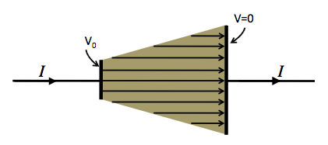

**C.** For this same situation, the diagram now shows one way that a student has drawn the electric field lines inside the resistor.

Which aspects of this drawing are correct, and which are incorrect? List as many as you can *in favor* of this drawing, and as many as you can *against* it.

[Hint: Try to answer for yourself questions like the following: Is charge conserved? Is the total current flowing constant? Is the divergence of the electric field inside the resistor correct? Are the boundary conditions satisfied? Are there other things that need to be considered?]

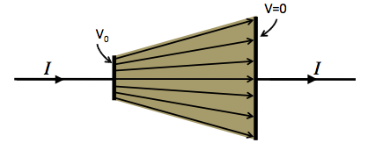

**D.** The diagram now shows another way that a student has drawn the electric field lines inside the resistor.

Which aspects of this drawing are correct, and which are incorrect? List as many as you can *in favor* of this drawing, and as many as you can *against* it.

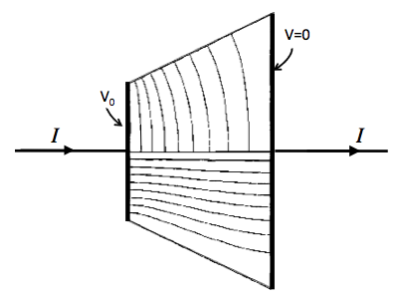**E.** The diagram now shows the correct *equipotential* lines (upper half) and correct *electric field* lines (lower half) inside this cone-shaped resistor.[1]

Explain how both of these sets of lines are consistent with the conditions that needed to be satisfied by the electric field inside the resistor, as you discussed on the previous pages.

**Challenge Question:** What can you conclude about the magnitude of the electric field as you get closer and closer to the bottom right-hand corner of the resistor? Explain your answer in terms of boundary conditions.

1. Credit to J. D. Romano and R. H. Price for finding this solution numerically.